**INDEX**

|  |  |  |
| --- | --- | --- |
| Sr.No | Description | Page No |
| 1 | **Introduction to E-Textile** | 02 |
|  | 1.1 Definition of E-Textiles | 02 |
|  | 1.2 Historical context and evolution | 04 |
|  | 1.3 Significance and applications in modern times. | 06 |
| 2 | **Fundamentals of E-Textiles** | 07 |
|  | 2.1 Basic components: conductive threads, fabrics, sensors, and actuators | 07 |
|  | 2.2 Overview of traditional textiles vs. e-textile. | 11 |
|  | 2.3 Conductive materials and their properties | 12 |
| 3 | **Electronic Components in E-Textiles** | 15 |
|  | 3.1 Basic components: conductive threads, fabrics, sensors, and actuators | 15 |
|  | 3.2 Programmable Platforms in E-Textiles: | 17 |
|  | 3.3 Sensors: types and applications | 19 |
|  | 3.4 Actuators: integrating movement and functionality | 21 |
|  | 3.5 Power sources for e-textiles | 24 |
| 4 | **Design and Construction** | 28 |
|  | 4.1 Design considerations for e-textile projects | 28 |
|  | 4.2 Techniques for integrating electronics into fabrics | 30 |
|  | 4.3 Case studies of successful e-textile design | 33 |
|  | 4.4 Troubleshooting common issues in construction | 35 |
| 5 | **Programming E-Textiles** | 39 |
|  | 5.1 Introduction to programming languages for e-textiles | 39 |
|  | 5.2 Code examples for basic functionalities | 42 |
|  | 5.3 Tips for debugging and testing code on e-textile projects | 44 |
| 6 | **Sensing and Interaction** | 46 |
|  | 6.1 Overview of sensing technologies in e-textiles | 46 |
|  | 6.2 Use cases for different sensors (temperature, pressure, touch) | 48 |
|  | 6.3 Interactive e-textile applications and examples | 51 |
| 7 | **Challenges and Future Trends** | 53 |
|  | 7.1 Current challenges in e-textile development | 53 |
|  | 7.2 Emerging technologies in the field | 55 |
|  | 7.3 Speculations on the future of e-textiles: | 57 |
| 8 | **Conclusion** | 59 |
|  | 8.1 Future Prospects | 60 |
|  | 8.2 Resources: | 61 |

**Introduction**

**1.1 Definition of E-Textiles**

Electronic textiles or e-textiles are fabrics that enable electronic components such as batteries, lights, sensors, and microcontrollers to be embedded in them. They are not to be confused with smart textiles, which are fabrics that have been developed with new technologies that provide added value. Many smart clothing, **wearable technology,** and **wearable computing** projects involve the use of e-textiles.

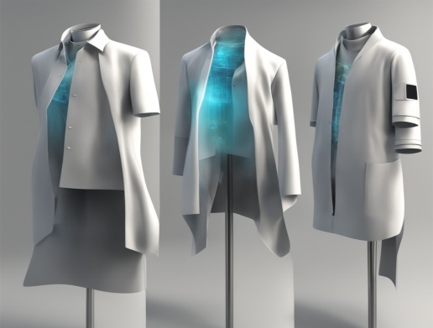

Electronic textiles are distinct from wearable computing because the emphasis is placed on the seamless integration of textiles with electronic elements like microcontrollers, sensors, and actuators. Furthermore, e-textiles need not be wearable. For instance, e-textiles are also found in interior design.

**Wearable technology**:- Wearable technology is any technology that is designed to be used while worn. Common types of wearable technology include smart watches and smart glasses. Wearable electronic devices are often close to or on the surface of the skin, where they detect, analyze, and transmit information such as vital signs, and/or ambient data and which allow in some cases immediate biofeedback to the wearer.

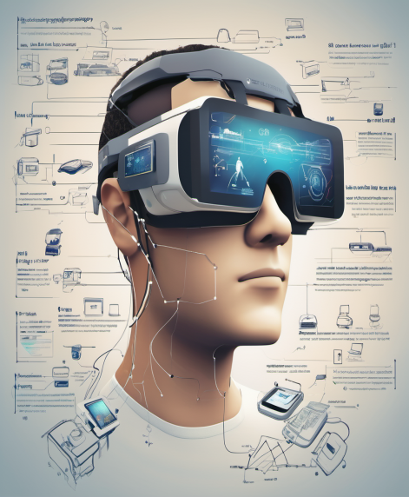

**Wearable computing:-** A wearable computer, also known as a body-borne computer,is a computing device worn on the body.The definition of 'wearable computer' may be narrow or broad, extending to smartphones or even ordinary wristwatches.

At their core, e-textiles seamlessly integrate electronics into the very fabric itself. This isn't about clunky gadgets attached to clothing; it's about yarns woven with conductive properties, creating fabrics that can sense touch, temperature, or even heart rate. Imagine a jacket that warms you up on a chilly night, or a shirt that glows when you approach your phone. The possibilities are truly endless.

At its core, E-textiles harness the power of technology to create fabrics that go beyond their conventional roles. Imagine clothing that not only adorns the body but also serves as a dynamic interface, capable of sensing, responding, and adapting to the wearer's needs. From smart athletic wear that monitors and enhances performance to fashionable garments embedded with responsive lighting, E-textiles redefine the boundaries of what our fabrics can achieve.

This intersection of textiles and electronics brings forth a myriad of possibilities across diverse domains. In the realm of healthcare, E-textiles contribute to the development of wearable medical devices that monitor vital signs and seamlessly integrate into patients' daily lives. In fashion, designers are exploring the creative potential of fabrics that can change color, texture, or even shape in response to environmental stimuli or user interactions.

The journey into E-textiles delves into the fascinating convergence of craftsmanship and technology, where the loom meets the microcontroller and the stitch intertwines with conductive threads. This documentation aims to unravel the intricacies of E-textiles, exploring their fundamental components, design considerations, programming intricacies, and the wide array of applications that showcase the versatility and impact of these electronic fabrics.

As we embark on this exploration, we invite you to weave through the threads of innovation, discovering how E-textiles are not just garments but conduits for creativity, functionality, and a glimpse into the future of wearable technology.

**1.2 Historical context and evolution**

In 1985, inventor Harry Wainwright created the first fully animated sweatshirt. The shirt consisted of fiber optics, leads, and a microprocessor to control individual frames of animation. The result was a full-color cartoon displayed on the surface of the shirt. in 1995, Wainwright went on to invent the first machine enabling fiber optics to be machined into fabrics, the process needed for manufacturing enough for mass markets and, in 1997, hired a German machine designer, Herbert Selbach, from Selbach Machinery to produce the world's first computer numerical control (CNC) machine able to automatically implant fiber optics into any flexible material. Receiving the first of a dozen patents based on LED/Optic displays and machinery in 1989, the first CNC machines went into production in 1998 beginning with the production of animated coats for Disney Parks in 1998. The first ECG bio-physical display jackets employing LED/optic displays were created by Wainwright and David Bychkov, the CEO of Exmovere at the time in 2005 using GSR sensors in a watch connected via Bluetooth to the embedded machine washable display in a denim jacket and was demonstrated at the Smart Fabrics Conference held in Washington, D.C. May 7, 2007. Additional smart fabric technologies were unveiled by Wainwright at two Flextech Flexible Display conferences held in Phoenix, AZ, showing infrared digital displays machine-embedded into fabrics for IFF (Identification of Friend or Foe) which were submitted to BAE Systems for evaluation in 2006 and won an "Honorable Mention" award from NASA in 2010 on their Tech Briefs, "Design the Future" contest. MIT personnel purchased several fully animated coats for their researchers to wear at their demonstrations in 1999 to bring attention to their "Wearable Computer" research. Wainwright was commissioned to speak at the Textile and Colorists Conference in Melbourne, Australia on June 5, 2012. He was requested to demonstrate his fabric creations that change color using any Smartphone, indicate callers on mobile phones without a digital display, and contain WIFI security features that protect purses and personal items from theft.

In the mid-1990s a team of MIT researchers led by Steve Mann, Thad Starner, and Sandy Pentland began to develop what they termed wearable computers. These devices consisted of traditional computer hardware attached to and carried on the body. In response to technical, social, and design challenges faced by these researchers, another group at MIT, which included Maggie Orth and Rehmi Post, began to explore how such devices might be more gracefully integrated into clothing and other soft substrates. Among other developments, this team explored integrating digital electronics with conductive fabrics and developed a method for embroidering electronic circuits. One of the first commercially available wearable Arduino based microcontrollers, called the Lilypad Arduino, was also created at the MIT Media Lab by Leah Buechley.

**1.3 Significance and applications in modern times.**

The integration of E-textiles into modern society is not merely a trend but a transformative leap that extends the boundaries of traditional fabrics. The significance of E-textiles lies in their ability to seamlessly blend technology into the garments we wear, opening up a plethora of applications that redefine how we interact with clothing and the world around us.

1. Wearable Health Monitoring

2. Responsive and Interactive Fashion

3. Sports and Performance Enhancement

4. Adaptive and Functional Clothing

5. Human-Computer Interaction (HCI):

6. Assistive Technologies:

7. Military and Industrial Applications:

The significance of E-textiles in modern times lies in their transformative impact on various aspects of our lives. As technology continues to advance, these electronic fabrics promise to play an increasingly integral role in shaping the future of clothing, healthcare, and human interaction. The fusion of textiles and technology not only enhances functionality but also prompts a reimagining of the very fabric of our daily experiences.

**Fundamentals of E-Textiles**

**2.1 Basic components: conductive threads, fabrics, sensors, and actuators**

**1. Conductive Threads:**

* + *Material:* Conductive threads are often made of materials like metal (such as silver-coated nylon or stainless steel), conductive polymers, or even carbon-based materials.
  + *Properties:* These threads have the ability to conduct electricity while still maintaining flexibility and compatibility with traditional sewing techniques.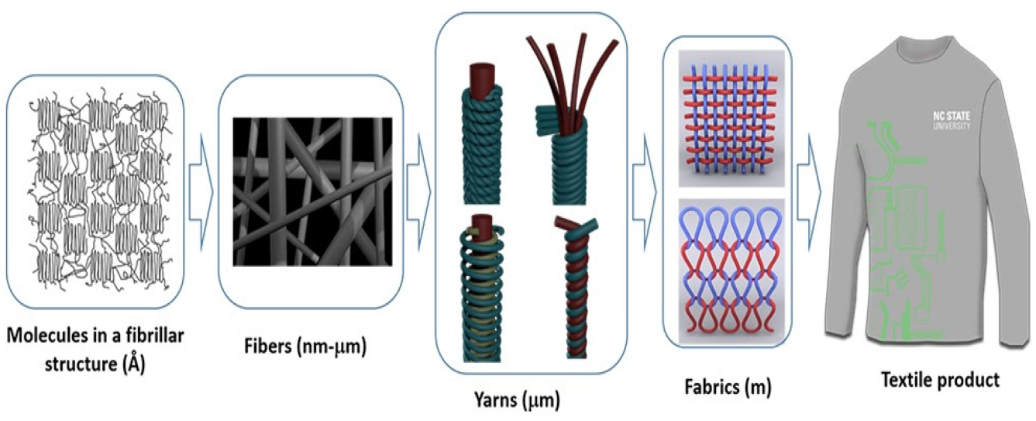
* *Usage:* Conductive threads are used for stitching or embroidering electronic components into the fabric. They form the conductive pathways that allow electrical signals to flow throughout the textile.

1. **Conductive Fabrics:**

* *Material:* Fabrics can be specially woven or coated with conductive materials like metal fibers (silver, copper) or conductive polymers.
* *Properties:* Conductive fabrics provide a flexible and conductive surface, allowing for the integration of electronic components while maintaining textile properties like softness and breathability.

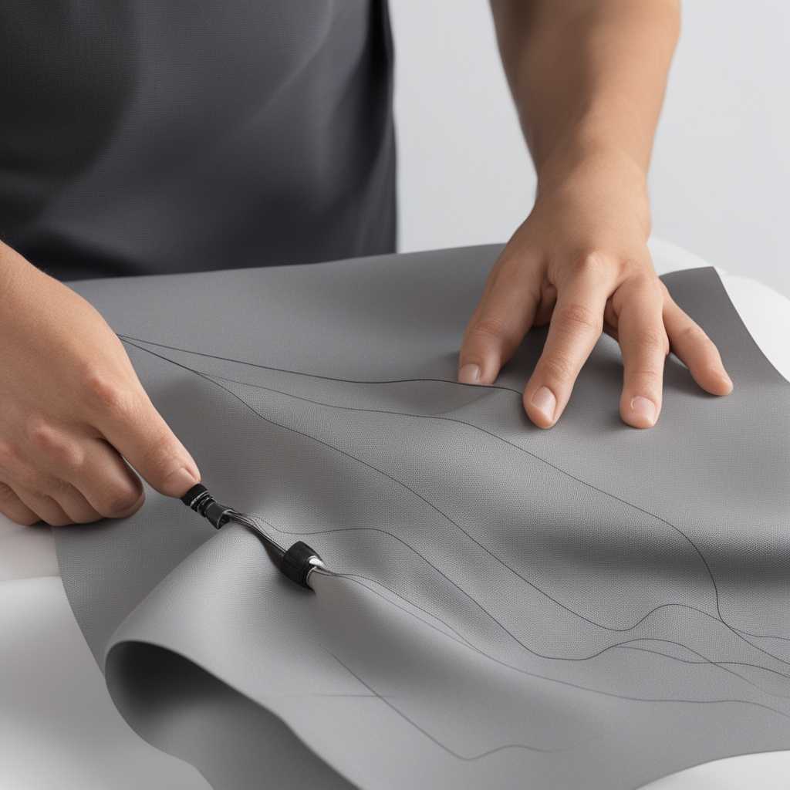

* *Usage:* These fabrics serve as the foundation for e-textiles, enabling the creation of smart garments and textiles with electronic functionality.

1. **Sensors**

* *Types:* Various sensors can be integrated, such as pressure sensors, temperature sensors, accelerometers, gyroscopes, and stretch/bend sensors.
* *Properties:* Sensors detect changes in the environment or the textile itself and convert these changes into electrical signals (analog or digital).

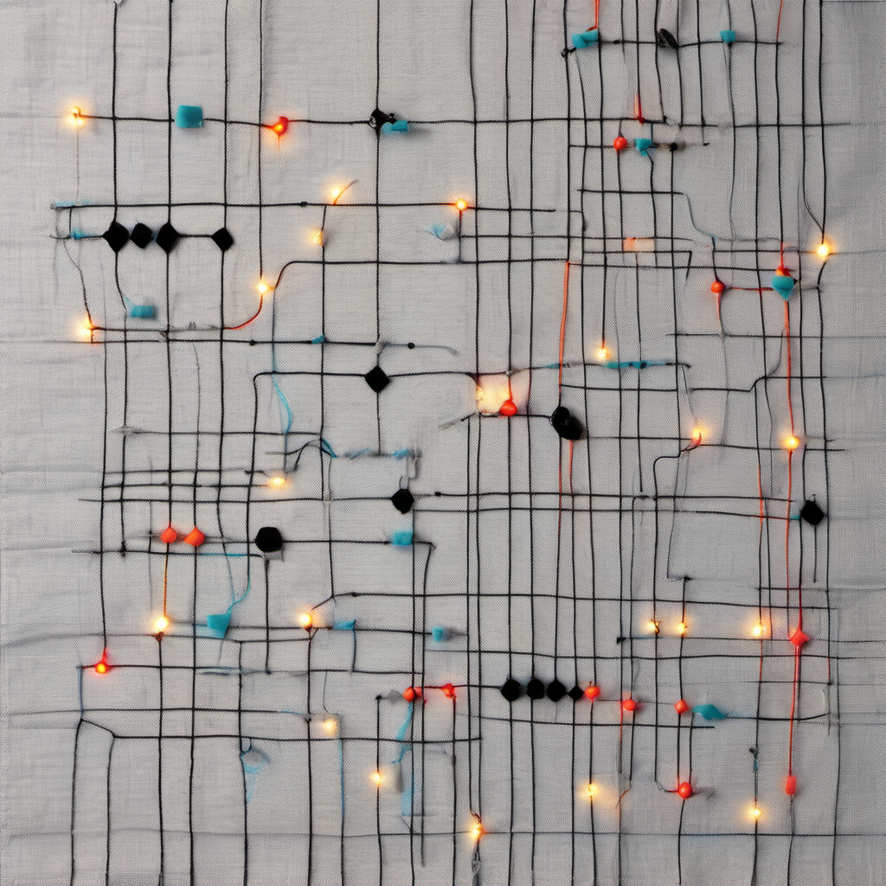

* *Usage:* Sensors are embedded within the textile to capture data about the wearer or the surrounding environment. For example, stretch sensors can detect body movements, and temperature sensors can monitor the wearer's body temperature.

1. **Actuators**

* *Types:* Actuators in e-textiles include LED lights, motors, or shape-memory alloys.
* *Properties:* Actuators respond to signals from sensors or microcontrollers, producing visible or tangible effects like light emission, movement, or changes in the textile's structure.

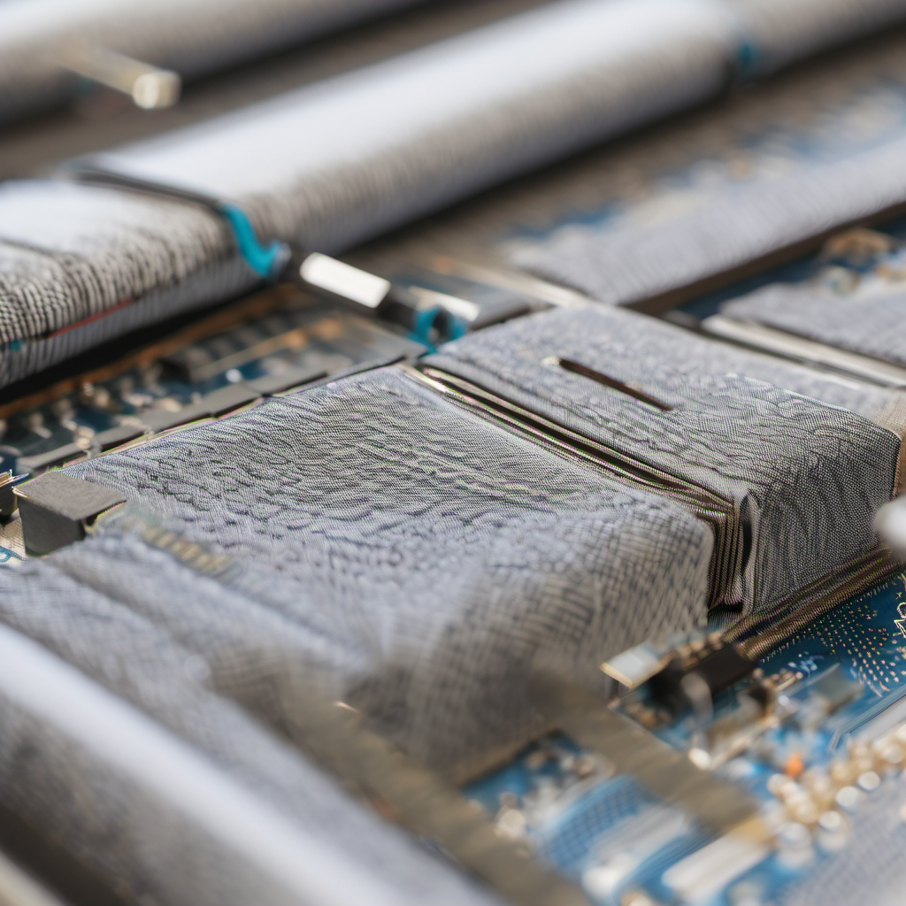

* *Usage:* Actuators add interactive and dynamic features to e-textiles. For instance, LED lights can create illuminated patterns on the fabric, or motors can enable haptic feedback

|  |  |  |
| --- | --- | --- |
| Aspect | Traditional Textiles | E-Textiles |
| Composition | Natural or synthetic fibers (cotton, wool, etc.) | Conductive threads/fabrics combined with traditional textile materials |
| Functionality | Primarily for clothing, shelter, and decoration | Active and interactive, responds to stimuli or user input |
| Applications | Clothing, home textiles, accessories | Wearable technology, smart clothing, interactive installations |
| Processing | Weaving, knitting, sewing | Sewing, embroidering, embedding electronic components |
| Interaction | Passive | Active and dynamic responses |
| Power Requirements | N/A (no electronic components) | Requires power sources (batteries) |
| Flexibility and Design | Traditional designs, static | Flexible design, integration of technology without compromising aesthetics |
| Examples | T-shirts, bed linens, curtains | Smart clothing, fitness trackers, interactive textiles |

**2.2 Overview of traditional textiles vs. e-textile.**

**2.3 Conductive materials and their properties**

1. **Metallic Wires:**
   * *Materials:* Copper, silver, gold, aluminum, and other metals.
   * *Properties:* Excellent conductivity, durability, and widely available. However, they are less flexible than some alternatives.
2. **Conductive Fabrics:**
   * *Materials:* Fabrics woven or coated with conductive materials like metal fibers (silver-coated nylon or stainless steel) or conductive polymers.
   * *Properties:* Flexible, lightweight, and capable of integrating with traditional textiles. They allow for the creation of conductive pathways while maintaining textile properties.
3. **Conductive Threads:**
   * *Materials:* Metal (silver, copper) or conductive polymers.
   * *Properties:* Thin and flexible threads that can be sewn or embroidered into fabrics. They are often used for creating conductive pathways in e-textiles without sacrificing flexibility.
4. **Conductive Inks/Paints:**
   * *Materials:* Graphite, silver, or other conductive particles suspended in a liquid base.
   * *Properties:* Applied as a liquid, allowing for flexible and customizable patterns on various surfaces. Suitable for creating conductive traces on fabrics or paper.
5. **Carbon Nanotubes:**
   * *Materials:* Cylindrical structures made of carbon atoms.
   * *Properties:* High electrical conductivity, lightweight, and extremely thin. Carbon nanotubes can be integrated into textiles to provide conductivity without adding significant weight.
6. **Conductive Polymers:**
   * *Materials:* Polymers doped with conductive materials, such as polyaniline or polythiophene.
   * *Properties:* Flexible and lightweight, conductive polymers offer unique electrical and mechanical properties. They can be applied as coatings or integrated into textiles to provide conductivity.
7. **Graphene:**
   * *Material:* A single layer of carbon atoms arranged in a hexagonal lattice.
   * *Properties:* Exceptional electrical conductivity, high flexibility, and strength. Graphene-based materials can be used to create conductive layers with minimal thickness.
8. **Silver Nanoparticles:**
   * *Material:* Tiny particles of silver.
   * *Properties:* High electrical conductivity, and they can be applied as coatings or inks. Silver nanoparticles are often used to create conductive surfaces on flexible substrates.
9. **Conductive Elastomers:**
   * *Materials:* Elastomers (rubber-like materials) embedded with conductive particles.
   * *Properties:* Combines flexibility with conductivity, making them suitable for applications where both properties are essential, such as stretchable electronic components.
10. **Printed Circuit Boards (PCBs):**
    * *Material:* Typically made of fiberglass-reinforced epoxy.
    * *Properties:* Rigid compared to other conductive materials, but widely used in electronic devices. They provide a stable platform for mounting electronic components and creating complex circuits.

**Electronic Components in E-Textiles**

* 1. **Microcontrollers and programmable platforms**

**Microcontrollers in E-Textiles:**

1. Definition:
   * *Microcontroller:* A compact integrated circuit that includes a processor, memory, and input/output peripherals. It is designed for embedded systems and can execute programmed instructions.

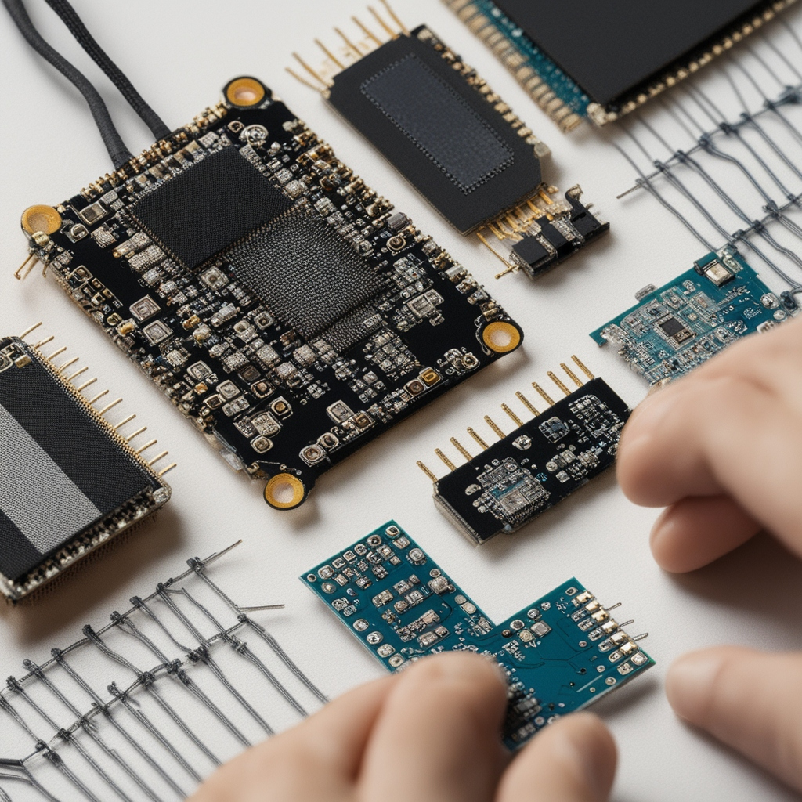

1. Key Functions:
   * *Processing:* Microcontrollers process data from sensors, interpret commands, and execute programmed instructions.
   * *Control:* They manage the operation of actuators, such as LEDs or motors, based on input from sensors or external signals.
   * *Communication:* Microcontrollers can facilitate communication between different components in the e-textile system.
2. Programming:
   * *Languages:* Microcontrollers are programmed using languages such as C, C++, or specialized languages like Arduino's Wiring.
   * *IDEs:* Integrated Development Environments (IDEs) like Arduino IDE or platform-specific tools are used for programming microcontrollers.
3. Common Microcontrollers:
   * *Arduino:* Arduino microcontrollers are widely used in e-textiles due to their simplicity, ease of programming, and a large supportive community.
   * *Micro:bit:* A pocket-sized microcontroller often used in educational settings for e-textile projects.
   * *LilyPad Arduino:* Specifically designed for e-textiles, it is round and has sewable connection points.
4. Integration with E-Textiles:
   * *Sewing and Embedding:* Microcontrollers in e-textiles are often sewn directly onto the fabric or embedded in pouches. Conductive threads connect them to other components.
5. Examples of Use:
   * *Gesture Sensing:* Microcontrollers can interpret signals from accelerometers or gyroscopes, allowing e-textiles to respond to specific gestures or movements.
   * *LED Displays:* Controlling the illumination patterns of LEDs embedded in the fabric.
   * *Interactive Textiles:* Enabling e-textiles to respond to environmental conditions or user input, creating interactive and dynamic experiences.

**3.2 Programmable Platforms in E-Textiles:**

1. Definition:
   * *Programmable Platform:* A broader term that includes various computing platforms that can be programmed for specific applications. This can include microcontrollers, FPGAs (Field-Programmable Gate Arrays), or other programmable devices.

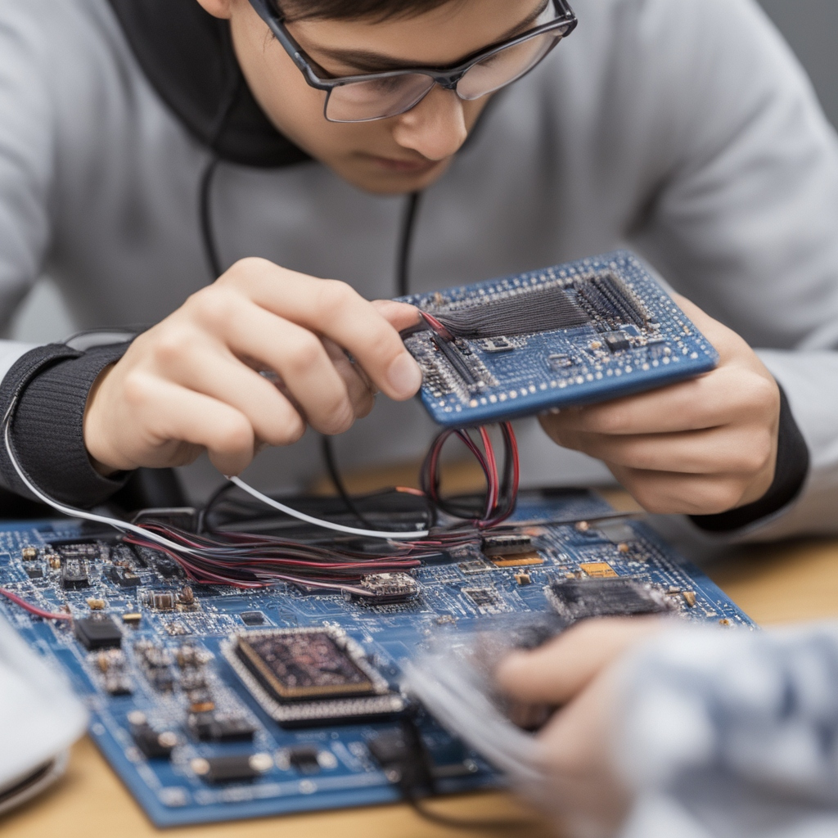

1. Flexibility:
   * *Adaptability:* Programmable platforms offer a higher level of adaptability and customization, allowing for more complex and specialized functionalities.
   * *Reprogrammability:* Unlike fixed-function devices, programmable platforms can be reprogrammed for different applications.
2. Advanced Features:
   * *FPGAs:* In addition to microcontrollers, FPGAs are programmable platforms that can be used for parallel processing and high-performance computing in e-textiles.
   * *Processing Power:* Depending on the application, more powerful platforms like single-board computers (e.g., Raspberry Pi) might be used for advanced computing tasks.
3. Examples of Use:
   * *Data Processing:* Handling complex algorithms for data analysis or machine learning applications in e-textiles.
   * *Wireless Communication:* Managing communication protocols like Bluetooth or Wi-Fi for connectivity in smart textiles.
   * *Edge Computing:* Performing computations locally within the textile, reducing the need for external processing.
   1. **Sensors: types and applications**

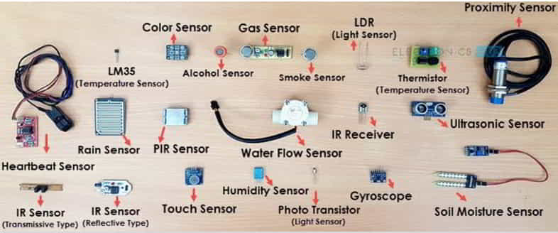

1. Pressure Sensors:
   * *Function:* Detect changes in pressure or compression.
   * *Applications:*
     + Smart footwear to analyze gait and detect abnormal pressure points.
     + Pressure-sensitive fabrics for interactive surfaces or gaming applications.
2. Stretch/Bend Sensors:
   * *Function:* Measure deformation or bending of the textile.
   * *Applications:*
     + Motion capture suits with embedded stretch sensors for tracking body movements.
     + Monitoring changes in fabric shape for posture correction in wearable devices.
3. Temperature Sensors:
   * *Function:* Measure changes in temperature.
   * *Applications:*
     + Monitoring body temperature in smart clothing for health applications.
     + Climate-controlled textiles that adjust to ambient temperature.
4. Accelerometers:
   * *Function:* Measure acceleration or changes in velocity.
   * *Applications:*
     + Gesture recognition in interactive clothing.
     + Fall detection in elderly care garments.
5. Gyroscopes:
   * *Function:* Measure orientation and angular velocity.
   * *Applications:*
     + Smart gloves for capturing hand movements.
     + Enhanced navigation features in garments for sports or fitness monitoring.
6. Light Sensors:
   * *Function:* Measure ambient light levels.
   * *Applications:*
     + Clothing with integrated light sensors for responsive illumination in different lighting conditions.
     + Sun exposure monitoring for UV protection in outdoor textiles.
7. Heart Rate Monitors:
   * *Function:* Measure heart rate.
   * *Applications:*
     + Smart shirts with embedded heart rate sensors for fitness tracking.
     + Health-monitoring garments for continuous heart rate assessment.
8. Electrodermal Activity (EDA) Sensors:
   * *Function:* Measure skin conductance and moisture.
   * *Applications:*
     + Stress-monitoring textiles for detecting emotional states.
     + Biofeedback garments for stress reduction.
9. EMG (Electromyography) Sensors:
   * *Function:* Measure electrical activity produced by muscles.
   * *Applications:*
     + Sports garments for analyzing muscle activity during training.
     + Assistive devices for individuals with motor impairments.
10. Capacitive Touch Sensors:
    * *Function:* Detect touch or proximity.
    * *Applications:*
      + Interactive surfaces on clothing for touch-sensitive controls.
      + Virtual keyboard integration in smart garments
    1. **Actuators: integrating movement and functionality**

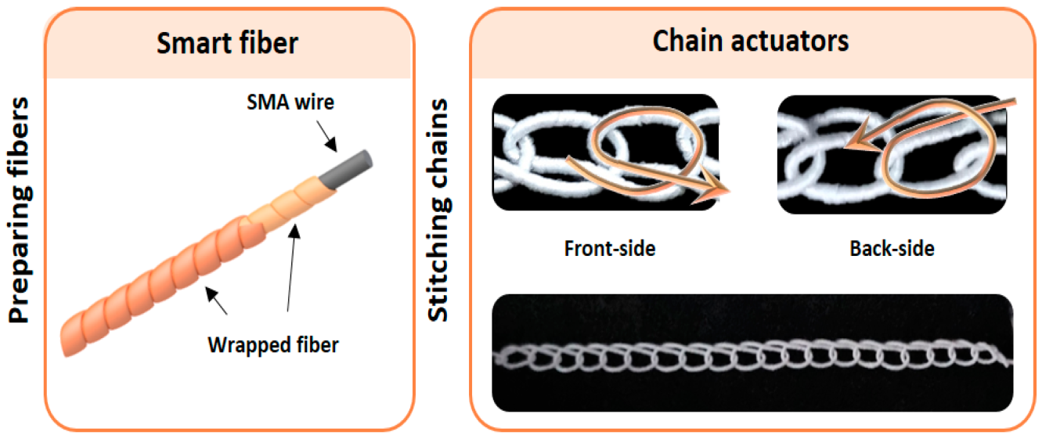

1. LED Lights:
   * *Function:* Emit light, often in various colors.
   * *Integration:* LEDs can be sewn into fabric and controlled by microcontrollers for interactive and illuminated textile designs.
2. Motors:
   * *Function:* Produce mechanical movement.
   * *Integration:* Small motors or vibration motors can be integrated for haptic feedback or to create dynamic textile structures.
3. Shape Memory Alloys (SMAs):
   * *Function:* Change shape when subjected to an electric current or heat.
   * *Integration:* SMAs can be woven into fabric, allowing the textile to change shape or create dynamic patterns when triggered.
4. Electroactive Polymers (EAPs):
   * *Function:* Change shape in response to an electric field.
   * *Integration:* EAPs can be used to create flexible and stretchable textiles that deform in response to electrical stimuli.
5. Pneumatic or Hydraulic Systems:
   * *Function:* Use air or liquid pressure to generate movement.
   * *Integration:* Inflatable or deflatable chambers can be embedded in textiles to achieve shape changes or movement.
6. Thermochromic Materials:
   * *Function:* Change color in response to temperature.
   * *Integration:* These materials can be used in combination with heating elements to create dynamic color-changing textiles.
7. Microvalves:
   * *Function:* Control the flow of fluids.
   * *Integration:* Integrated into textiles for applications like moisture regulation or to create patterns in wetting and drying.

**Integrating Movement and Functionality in E-Textiles:**

1. Interactive Clothing:
   * *Example:* Dresses or jackets with embedded LEDs that respond to motion or environmental factors.
   * *Integration:* Accelerometers or gyroscopes detect movement, triggering the activation of LEDs or other actuators.
2. Haptic Feedback:
   * *Example:* Smart gloves with embedded vibration motors for tactile feedback.
   * *Integration:* Motors are activated based on input from sensors, providing a tactile response to the wearer.
3. Shape-Changing Garments:
   * *Example:* Garments with embedded shape memory alloys for dynamic silhouettes.
   * *Integration:* SMAs are woven into the fabric and activated to change the garment's shape in response to specific conditions.
4. Wearable Displays:
   * *Example:* Clothing with integrated LED displays.
   * *Integration:* LED arrays controlled by microcontrollers can display patterns or messages based on input or pre-programmed instructions.
5. Thermoregulation:
   * *Example:* Clothing with embedded heating elements.
   * *Integration:* Sensors monitor the wearer's body temperature, activating heating elements to provide warmth when needed.
6. Dynamic Textile Structures:
   * *Example:* Fabrics with embedded pneumatic or hydraulic systems for shape-changing structures.
   * *Integration:* Chambers filled with air or liquid can be inflated or deflated to create dynamic textile forms.
7. Fluidic Fashion:
   * *Example:* Clothing with embedded microvalves for moisture control.
   * *Integration:* Microvalves regulate the flow of fluids, allowing for adaptive textiles that respond to environmental conditions.

**3.5 Power sources for e-textiles**

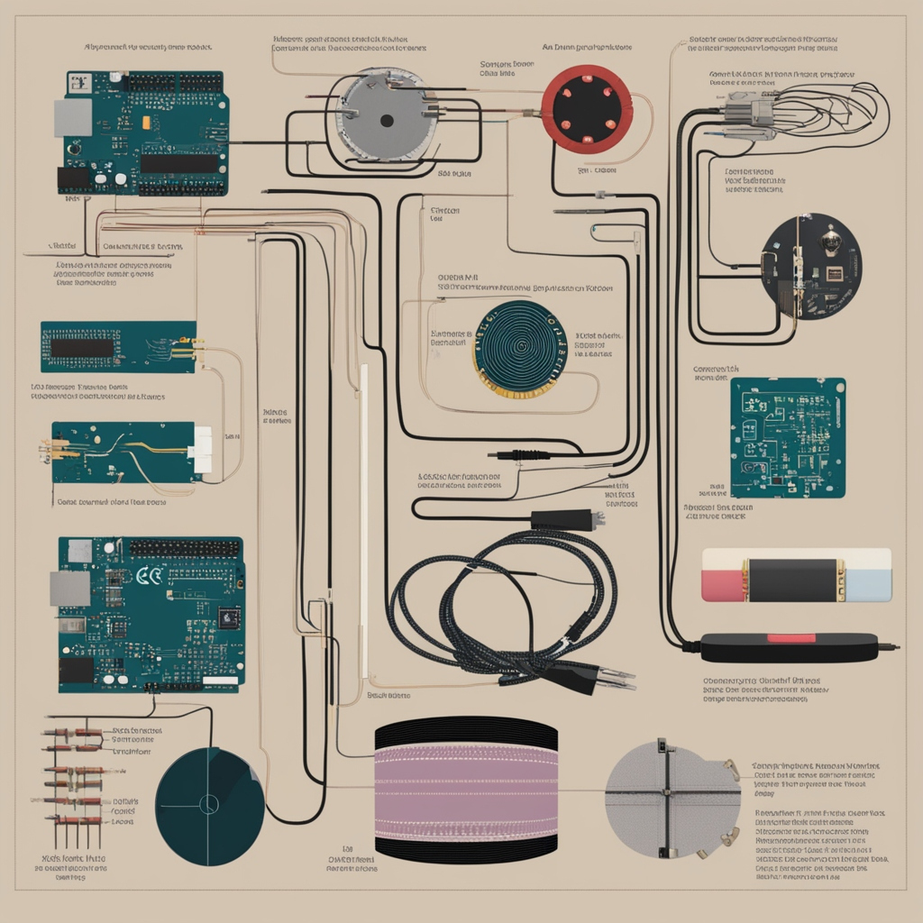

1. Batteries:

* *Type:* Lithium-ion, coin cell batteries, rechargeable batteries.
* *Pros:*
  + Compact and lightweight.
  + Available in various sizes and capacities.
* *Cons:*
  + Limited capacity, may require frequent replacement or recharging.
  + Adds weight to the garment.

2. Energy Harvesting:

* *Methods:* Solar cells, thermoelectric generators, piezoelectric materials.
* *Pros:*
  + Harness energy from the environment (sunlight, heat, or movement).
  + Can extend the lifespan of battery-powered systems.
* *Cons:*
  + Limited power generation in certain conditions.
  + Initial setup complexity.

3. Supercapacitors:

* *Type:* Electrochemical double-layer capacitors.
* *Pros:*
  + Fast charging and discharging.
  + Longer lifespan compared to traditional batteries.
* *Cons:*
  + Lower energy density compared to batteries.
  + Bulkier than traditional batteries for similar energy storage.

4. Conductive Textiles with Embedded Energy Storage:

* *Type:* Fabrics with integrated energy storage components.
* *Pros:*
  + Seamless integration into the textile structure.
  + Provides flexibility in design.
* *Cons:*
  + Limited energy storage capacity.
  + May require specific manufacturing processes.

5. Wireless Power Transfer:

* *Methods:* Inductive or resonant coupling.
* *Pros:*
  + Eliminates the need for physical connectors.
  + Suitable for low-power devices.
* *Cons:*
  + Limited range and efficiency.
  + Energy loss during transmission.

6. Flexible Batteries:

* *Type:* Batteries designed to be flexible and conform to textile structures.
* *Pros:*
  + Seamless integration into flexible garments.
  + Available in various form factors.
* *Cons:*
  + Limited energy density compared to rigid batteries.
  + May have specific handling requirements.

7. Printed Batteries:

* *Type:* Batteries created using printing techniques.
* *Pros:*
  + Enables custom shapes and sizes.
  + Can be integrated during the textile manufacturing process.
* *Cons:*
  + Limited energy density compared to traditional batteries.
  + Requires specialized manufacturing equipment.

**Considerations for Choosing Power Sources in E-Textiles:**

1. Energy Requirements:
   * Assess the power needs of the electronic components and select a power source that can provide sufficient energy for the intended functionality.
2. Size and Weight:
   * Consider the size and weight constraints of the garment or textile. Choose a power source that balances energy capacity with practicality.
3. Integration:
   * Ensure that the chosen power source can be seamlessly integrated into the textile structure without compromising comfort or flexibility.
4. Durability:
   * Consider the durability and lifespan of the power source, especially in the context of frequent bending, stretching, or washing in the case of wearable textiles.
5. Charging and Replacement:
   * Evaluate the ease of recharging or replacing the power source. Consider user convenience and the overall lifespan of the e-textile.
6. Safety:
   * Choose power sources that adhere to safety standards, especially when designing wearable textiles that come into direct contact with the skin.
7. Cost:
   * Consider the cost of the power source, including initial investment and any ongoing maintenance or replacement expenses.

**Design and Construction**

**4.1 Design considerations for e-textile projects**

1. Material Selection:

* Textile Materials: Choose textiles that are comfortable, breathable, and suitable for the intended application (clothing, accessories, etc.).
* Conductive Materials: Select conductive threads, fabrics, and other materials compatible with both electronic components and traditional textile manufacturing.

2. Comfort and Wearability:

* Ensure the e-textile is comfortable for prolonged wear.
* Minimize bulkiness and weight to enhance wearability.
* Consider factors like flexibility, stretchability, and softness to maintain the feel of traditional textiles.

3. Integration of Electronic Components:

* Seamlessly integrate electronic components like sensors, actuators, and microcontrollers into the textile structure.
* Consider user comfort and avoid sharp edges or hard components that may irritate the skin.

4. Flexibility and Durability:

* Design for flexibility to accommodate body movements.
* Consider the durability of both textile and electronic components, especially in garments subject to frequent movement and washing.

5. Power Management:

* Choose an appropriate power source that aligns with the energy requirements and design constraints.
* Consider energy-efficient components to extend battery life or implement energy harvesting techniques.

6. User Interface and Interaction:

* Design intuitive interfaces for user interaction.
* Ensure controls are accessible and functional without compromising the aesthetics.

7. Aesthetics and Fashion:

* Consider the visual design, color, and overall aesthetics to align with fashion trends or specific design objectives.
* Ensure that electronic components do not compromise the overall appearance of the textile.

8. Washability and Maintenance:

* Design with washability in mind, considering the laundering requirements of the textile.
* Choose electronic components that can withstand washing or design removable modules for maintenance.

9. Scalability and Modularity:

* Design projects with scalability in mind to accommodate different sizes or applications.
* Consider modular designs that allow for easy upgrades or replacements of electronic components.

10. Safety:

* Ensure the safety of users by selecting materials that are non-toxic and hypoallergenic.
* Follow safety standards for electronic components, especially when integrated into wearable items.

11. Ease of Assembly and Reparability:

* Design for ease of assembly to simplify manufacturing processes.
* Consider reparability by using connectors or other methods that allow for the replacement of individual components.

12. Testing and Prototyping:

* Implement testing phases to identify and address issues related to functionality, comfort, and durability.
* Create prototypes to validate design concepts and gather user feedback.

13. Regulatory Compliance:

* Familiarize yourself with regulatory requirements for wearable electronics and e-textiles.
* Ensure that the final product complies with safety and performance standards.

14. Environmentally Conscious Design:

* Consider the environmental impact of materials and components used in the e-textile.
* Design with sustainability in mind, promoting recyclability and minimizing electronic waste.

15. Collaboration and Interdisciplinary Approach:

* Foster collaboration between textile designers and electronics engineers to ensure a holistic and successful integration of both disciplines.
* Encourage an interdisciplinary approach to problem-solving and innovation.
  1. **Techniques for integrating electronics into fabrics**

1. Sewing and Embroidery:

* Method: Use conductive threads to sew electronic components onto or into the fabric.
* Application: Ideal for attaching sensors, actuators, and even microcontrollers to create flexible and conductive pathways.

2. Iron-On or Fusible Interfacing:

* Method: Apply fusible interfacing with conductive properties to bond electronic components to fabric using heat.
* Application: Suitable for adding conductive patches, traces, or components to the fabric without traditional sewing.

3. Conductive Adhesives:

* Method: Use conductive adhesives to attach electronic components directly onto fabric.
* Application: Suitable for attaching sensors, LEDs, or other components where sewing may not be practical.

4. Embroidered Circuitry:

* Method: Use specialized machines or hand embroidery techniques to create conductive pathways on fabric.
* Application: Enables the creation of intricate and customized conductive patterns directly on the textile.

5. Knitting and Crocheting:

* Method: Incorporate conductive yarns or threads into knitted or crocheted textiles.
* Application: Create garments with integrated conductive elements, such as heating elements or touch-sensitive surfaces.

6. Screen Printing:

* Method: Use conductive inks to screen print electronic circuits directly onto fabric.
* Application: Ideal for creating large and flexible electronic surfaces, such as touch-sensitive panels.

7. Dielectric Elastomer Actuators:

* Method: Embed dielectric elastomer actuators into fabric to enable shape-changing properties.
* Application: Used for creating dynamic and responsive textile structures that change shape in response to electrical stimuli.

8. Lamination:

* Method: Laminate flexible circuit boards or electronic components onto fabric using heat or adhesives.
* Application: Suitable for integrating rigid electronic elements into textiles while maintaining flexibility.

9. 3D Printing:

* Method: 3D print conductive materials directly onto fabric or create conductive structures.
* Application: Enables the fabrication of three-dimensional conductive elements on textiles for various applications.

10. Weaving with Conductive Threads:

* Method: Integrate conductive threads into the weft or warp during the weaving process.
* Application: Create woven fabrics with embedded conductive pathways, suitable for a wide range of e-textile applications.

11. Spray Coating:

* Method: Use conductive spray coatings to add conductive properties to the fabric surface.
* Application: Provides a uniform conductive layer, suitable for creating touch-sensitive surfaces.

12. Soft Circuits:

* Method: Use flexible materials, conductive tapes, and connectors to create soft circuits.
* Application: Ideal for applications where flexibility and comfort are crucial, such as in wearable health monitoring devices.

13. Integration with Traditional Garment Manufacturing:

* Method: Collaborate with garment manufacturers to integrate electronic components during the traditional manufacturing process.
* Application: Ensures that electronic components are seamlessly integrated into the garment from the beginning of the production process.

14. Wireless Modules:

* Method: Integrate wireless communication modules into fabrics.
* Application: Allows for remote communication between electronic components, reducing the need for physical connections.
  1. **Case studies of successful e-textile design**

**1. Project Jacquard by Google and Levi's:**

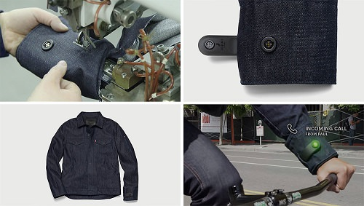

**Overview:**

* *Collaborators:* Google ATAP (Advanced Technology and Projects) and Levi's
* *Year:* Announced in 2015, commercial launch in 2017
* *Description:* Project Jacquard is a collaboration between Google and Levi's to create smart clothing by weaving conductive threads into traditional denim fabric.

**Design and Implementation:**

* *Conductive Yarns:* Conductive yarns were woven into the fabric to create touch-sensitive areas on the clothing.
* *Sensor Integration:* Capacitive touch sensors were incorporated, allowing users to interact with their garments by tapping or swiping on specific areas.
* *Gestures and Connectivity:* The woven fabric allowed for gestures like swiping, tapping, and double-tapping, enabling interaction with smartphones or other connected devices.
* *Modularity:* The technology was integrated into everyday clothing items, making it seamlessly blend with the existing fashion line.

**Applications:**

* *Smart Jackets:* The first commercial product, the Levi's Commuter Trucker Jacket, featured the Project Jacquard technology. Wearers could control music, receive navigation prompts, and answer calls by interacting with the fabric on the sleeve.
* *Expansion:* The success of the initial jacket led to the development of additional products, including a backpack and other clothing items.

Outcome:

* *Market Impact:* Project Jacquard demonstrated the potential for integrating technology into everyday clothing, blurring the lines between fashion and functionality.
* *Consumer Adoption:* The project marked a significant step toward the mainstream adoption of smart textiles.

1. **Solar Shirt by Pauline van Dongen:**

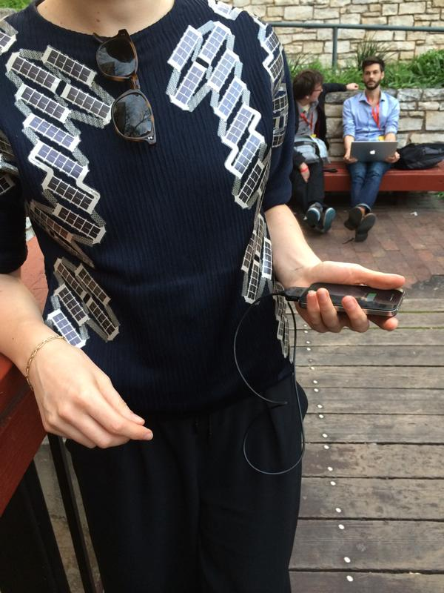

**Overview:**

* *Designer:* Pauline van Dongen
* *Year:* First introduced in 2015
* *Description:* The Solar Shirt is a wearable technology design by fashion tech designer Pauline van Dongen, incorporating solar panels into a stylish garment.

**Design and Implementation:**

* *Solar Cells:* Thin and flexible solar cells were integrated into the fabric of the shirt.
* *Placement:* The solar cells were strategically placed on the shoulders, where they could receive sunlight exposure even when the wearer was indoors.
* *Charging Capability:* The solar cells were connected to a battery pack, allowing the shirt to capture and store solar energy.

**Applications:**

* *Charging Devices:* The Solar Shirt demonstrated the possibility of integrating solar technology into fashion to charge small electronic devices such as smartphones.
* *Fashion and Sustainability:* The project highlighted the potential for combining fashion design with sustainable and eco-friendly technologies.

**Outcome:**

* *Recognition:* The Solar Shirt received attention for its innovative approach to combining fashion and technology.
* *Inspiration:* The project inspired discussions about the role of wearables in sustainability and energy harvesting within the fashion industry.
  1. **Troubleshooting common issues in construction**

1. Connection Issues:

* Problem: Unreliable or intermittent connections between electronic components.
* Troubleshooting:
  + Check soldered or sewn connections for breaks or loose connections.
  + Verify the integrity of conductive pathways using a multimeter.
  + Ensure that connectors are securely attached.

2. Short Circuits:

* Problem: Unexpected connections between conductive pathways, leading to malfunction or damage.
* Troubleshooting:
  + Inspect conductive paths for accidental overlaps or bridges.
  + Use insulating materials, such as fabric or non-conductive thread, to prevent unintended connections.
  + Verify the continuity of conductive paths with a multimeter.

3. Power Supply Issues:

* Problem: Unstable power supply or unexpected power drain.
* Troubleshooting:
  + Check the power source for proper voltage and current output.
  + Inspect power cables and connections for damage.
  + Test electronic components individually to identify power-consuming issues.

4. Sensor Calibration Problems:

* Problem: Sensors providing inaccurate readings or not responding correctly.
* Troubleshooting:
  + Recalibrate sensors according to manufacturer guidelines.
  + Ensure proper connections between sensors and microcontrollers.
  + Check for interference from nearby electronic devices.

5. Actuator Malfunctions:

* Problem: Actuators not responding as expected or not moving.
* Troubleshooting:
  + Verify the power supply to actuators.
  + Check for damaged or disconnected wiring leading to the actuators.
  + Test actuators independently to ensure functionality.

6. Programming Errors:

* Problem: Unexpected behavior due to errors in the code.
* Troubleshooting:
  + Review the code for syntax errors, logical issues, or typos.
  + Use debugging tools or print statements to identify where the code deviates from expectations.
  + Check for compatibility issues between hardware and software.

7. Wearable Comfort Issues:

* Problem: The e-textile is uncomfortable or causing irritation to the wearer.
* Troubleshooting:
  + Ensure that electronic components are securely attached and do not poke or scratch.
  + Use soft, flexible materials for conductive pathways and components.
  + Consider the placement of components to avoid pressure points.

8. Environmental Factors:

* Problem: E-textile performance affected by environmental conditions.
* Troubleshooting:
  + Protect electronic components from moisture by using waterproof materials or coatings.
  + Shield sensors from electromagnetic interference.
  + Consider environmental factors during the design phase to minimize impact.

9. Fabric Wear and Tear:

* Problem: Conductive threads or fabrics deteriorating over time.
* Troubleshooting:
  + Choose durable and washable conductive materials.
  + Reinforce high-stress areas with additional stitching or fabric.
  + Test fabric samples for longevity before full-scale production.

10. Inadequate Documentation:

* Problem: Lack of clear documentation for construction and troubleshooting.
* Troubleshooting:
  + Maintain detailed documentation for the entire construction process.
  + Include schematics, connection diagrams, and code comments.
  + Provide troubleshooting guidelines for future reference.

**Programming E-Textiles**

* 1. **Introduction to programming languages for e-textiles**

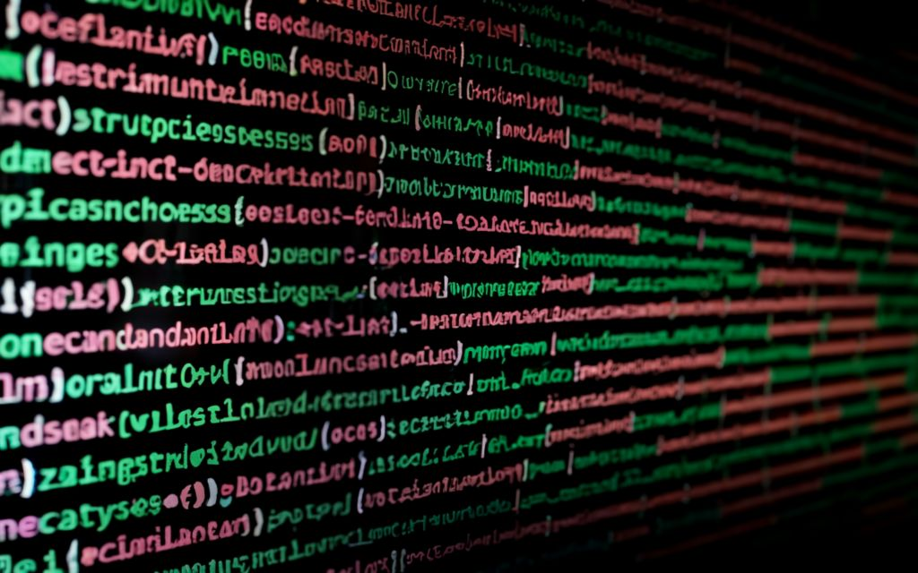

**1. Arduino (C/C++):**

* **Description:** Arduino is a popular open-source electronics platform based on a simplified version of C and C++. It is widely used in e-textiles due to its simplicity and a large supportive community.
* **Application:** Suitable for programming microcontrollers in e-textile projects. Arduino IDE is commonly used for development.

**2. Python:**

* **Description:** Python is a versatile, high-level programming language known for its readability and ease of use. It is often used for higher-level tasks in e-textile projects, such as data analysis and interaction with other software components.
* **Application:** Ideal for tasks like data processing, machine learning, or interfacing e-textile projects with other software.

**3. Processing (Java-based):**

* **Description:** Processing is a programming language and environment built for visual arts and creative coding. It is based on Java and is used for creating interactive graphics and visualizations.
* **Application:** Suitable for designing interactive and visually engaging e-textile projects, especially those involving LED displays or visual feedback.

**4. JavaScript:**

* **Description:** JavaScript is a versatile scripting language commonly used for web development. In e-textiles, it can be used for creating interactive and web-connected wearables.
* **Application:** Ideal for projects where a web-based interface or connectivity with web services is required.

**5. MicroPython:**

* **Description:** MicroPython is a lean and efficient implementation of Python 3 for microcontrollers. It brings Python to the world of embedded systems.
* **Application:** Suitable for projects where Python syntax is preferred, and memory constraints are a concern, as MicroPython is designed for resource-constrained environments.

**6. Blockly (Visual Programming):**

* **Description:** Blockly is a visual programming language that uses a drag-and-drop interface to create code by stacking visual blocks. It is often used in educational settings.
* **Application:** Suitable for introducing programming concepts to beginners or for creating visual programming interfaces for e-textiles.

**7. Scratch (Visual Programming):**

* **Description:** Scratch is a visual programming language developed by MIT. It uses a block-based interface and is designed for beginners, especially children, to learn programming.
* **Application:** Suitable for educational e-textile projects where a graphical interface can simplify the learning process.

**8. LabVIEW:**

* **Description:** LabVIEW is a graphical programming language often used in engineering and scientific applications. It is designed for data acquisition, instrument control, and automation.
* **Application:** Suitable for e-textile projects that involve complex data processing or integration with laboratory equipment.

**9. Rust:**

* **Description:** Rust is a systems programming language known for its focus on performance, memory safety, and zero-cost abstractions. It is gaining popularity for embedded systems development.
* **Application:** Suitable for e-textile projects where low-level control and efficiency are critical, and the project demands performance optimization.
  1. **Code examples for basic functionalities**
* **Blink an LED:**

// LED Blink example for Arduino

const int ledPin = 13; // Digital pin for the LED

void setup() {

pinMode(ledPin, OUTPUT); // Set the LED pin as an output

}

void loop() {

digitalWrite(ledPin, HIGH); // Turn the LED on

delay(1000); // Wait for 1 second

digitalWrite(ledPin, LOW); // Turn the LED off

delay(1000); // Wait for 1 second

}

* **Control RGB LED Colors:**

// RGB LED Control example for Arduino

const int redPin = 9; // Digital pin for the red LED

const int greenPin = 10; // Digital pin for the green LED

const int bluePin = 11; // Digital pin for the blue LED

void setup() {

pinMode(redPin, OUTPUT); // Set the red pin as an output

pinMode(greenPin, OUTPUT); // Set the green pin as an output

pinMode(bluePin, OUTPUT); // Set the blue pin as an output

}

void loop() {

analogWrite(redPin, 255); // Set red LED to maximum brightness

analogWrite(greenPin, 0); // Turn off green LED

analogWrite(bluePin, 0); // Turn off blue LED

delay(1000); // Wait for 1 second

analogWrite(redPin, 0); // Turn off red LED

analogWrite(greenPin, 255); // Set green LED to maximum brightness

analogWrite(bluePin, 0); // Turn off blue LED

delay(1000); // Wait for 1 second

analogWrite(redPin, 0); // Turn off red LED

analogWrite(greenPin, 0); // Turn off green LED

analogWrite(bluePin, 255); // Set blue LED to maximum brightness

delay(1000); // Wait for 1 second

**}**

* **Interactive LED with Push Button:**

// Interactive LED with Push Button example for Arduino

const int buttonPin = 2; // Digital pin for the push button

const int ledPin = 13; // Digital pin for the LED

void setup() {

pinMode(buttonPin, INPUT_PULLUP); // Set the button pin as an input with pull-up resistor

pinMode(ledPin, OUTPUT); // Set the LED pin as an output

}

void loop() {

if (digitalRead(buttonPin) == LOW) { // If the button is pressed

digitalWrite(ledPin, HIGH); // Turn the LED on

} else {

digitalWrite(ledPin, LOW); // Turn the LED off

}

* 1. **Tips for debugging and testing code on e-textile projects**

1. Use Serial Communication:

* Implement serial print statements in your code to output relevant information. This is especially useful for reading sensor values, checking variable states, or identifying where the code may encounter issues.

cpSerial.begin(9600);

Serial.println("Debugging information: " + String(variableValue));

2. Incremental Testing:

* Test individual components and functionalities separately before integrating them into the complete system. This helps identify issues at an early stage and makes troubleshooting more manageable.

3. Multimeter and Oscilloscope:

* Use a multimeter to measure voltage, resistance, and continuity in your circuits. An oscilloscope can help visualize signals and troubleshoot issues related to timing and waveforms.

4. Breadboard Prototyping:

* Before integrating components into textiles, use a breadboard for prototyping. This allows you to validate your circuit and code before committing to the fabric, making it easier to identify and fix issues.

5. Check Power Supply:

* Ensure that your power supply (battery or other source) is providing the correct voltage and current for your components. Unstable power can lead to erratic behavior in e-textile systems.

6. Inspect Connections:

* Regularly check physical connections, especially those involving conductive threads or fabrics. Loose or damaged connections can cause intermittent issues.

7. Isolate Issues:

* Temporarily isolate different sections of your code or components to identify the source of the problem. This can involve commenting out code or disconnecting specific components.

8. Instrumentation and Debugging Tools:

* Explore debugging tools available for your microcontroller platform. Some platforms provide tools for real-time debugging, variable inspection, and code stepping.

9. Logic Analyzers:

* Use logic analyzers to capture and analyze digital signals. This is particularly helpful for troubleshooting issues related to digital communication protocols.

10. Visual Inspection:

* Physically inspect your e-textile for loose threads, damaged components, or other anomalies. A visual inspection can sometimes reveal issues that are not apparent in the code.

11. Environmental Factors:

* Consider the environment in which your e-textile will be used. Factors such as humidity, temperature, and physical stress can impact the performance of electronic components.

12. Version Control:

* Use version control systems (e.g., Git) to keep track of changes in your code. This allows you to roll back to a working version if needed.

13. Documentation:

* Maintain detailed documentation, including circuit diagrams, code comments, and notes on the construction process. This documentation can be invaluable when troubleshooting or passing the project to others.

14. Collaborate and Seek Feedback:

* Collaborate with others and seek feedback. Sometimes, a fresh perspective can help identify issues that you might have overlooked.

**Sensing and Interaction**

* 1. **Overview of sensing technologies in e-textiles**

**1. Conductive Textiles:**

* Description: Conductive textiles are fabrics woven or coated with conductive materials, such as metal threads (silver, copper) or conductive inks. These materials allow for the creation of conductive pathways within the fabric.

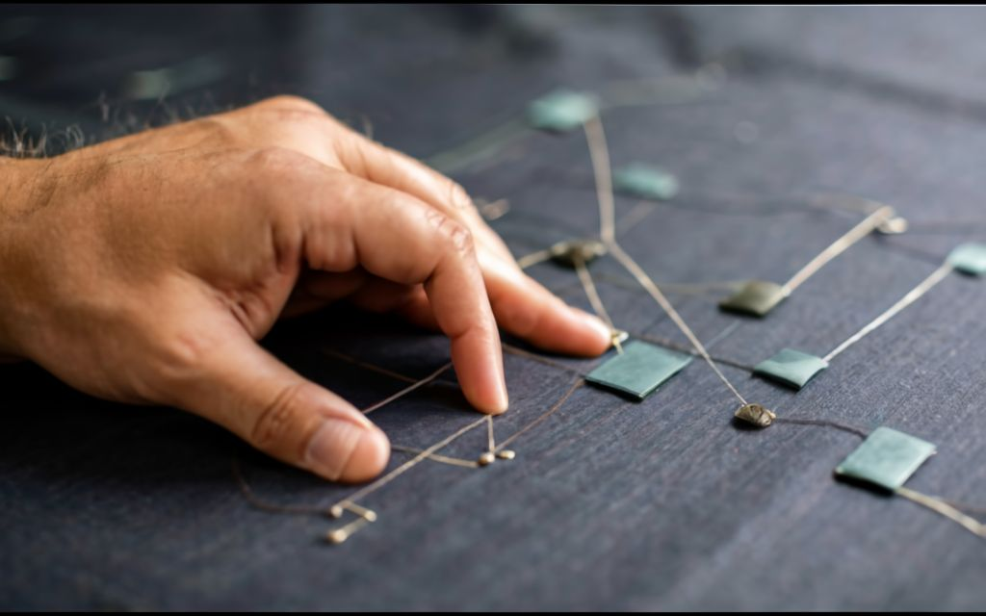

* Applications:
  + Touch-sensitive surfaces: Incorporating touch-sensitive areas into garments.
  + Interconnecting electronic components: Providing pathways for electrical signals.

**2. Flex Sensors:**

* Description: Flex sensors are flexible devices that change their resistance when bent or deformed. They are typically constructed with a resistive material that varies its resistance based on the degree of flex.

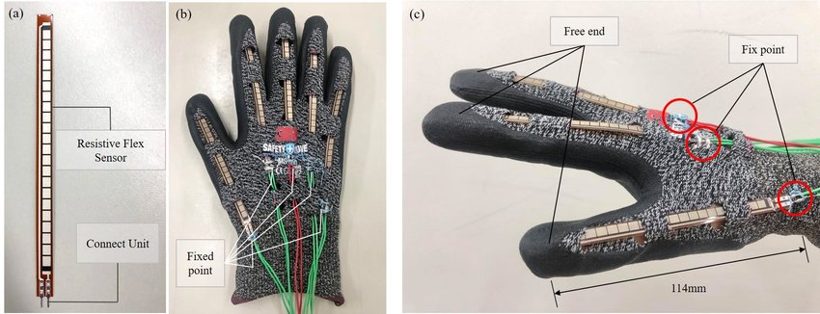

* Applications:
  + Motion tracking: Monitoring joint movements in sports wearables.
  + Prosthetics: Integrating into gloves or sleeves for finger movement detection.
  1. **Use cases for different sensors (temperature, pressure, touch)**

**1. Temperature Sensors:**

Use Case 1: Climate-Controlled Clothing

* Description: Integrating temperature sensors into clothing to create climate-controlled garments.
* Application: The temperature sensors monitor the wearer's body temperature, adjusting the fabric properties, such as ventilation or heating elements, to maintain optimal comfort. This is particularly useful in outdoor activities, sportswear, or environments with variable temperatures.

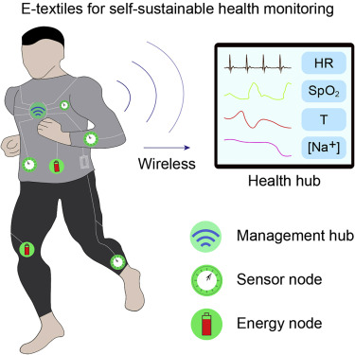

Use Case 2: Health Monitoring

* Description: Employing temperature sensors for health-related applications.
* Application: Monitoring body temperature in real-time can be crucial for health tracking. Wearable garments with embedded temperature sensors can assist in early fever detection, aid in tracking menstrual cycles, or contribute to sleep analysis.

Use Case 3: Smart Bedding

* Description: Utilizing temperature sensors in beddings and sleepwear for enhanced sleep quality.
* Application: Embedded temperature sensors can adjust the temperature of smart blankets or mattress pads, creating a comfortable sleep environment. This promotes better sleep quality by adapting to the user's preferences or optimizing the bed climate for improved rest.

**2. Pressure Sensors:**

Use Case 1: Posture Correction Garments

* Description: Implementing pressure sensors to create garments that encourage proper posture.
* Application: Pressure sensors can be strategically placed in areas prone to poor posture. When the sensors detect incorrect posture, the garment provides haptic feedback, reminding the wearer to adjust their stance. This is beneficial for preventing back pain and promoting better spinal alignment.

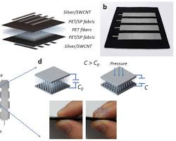

Use Case 2: Smart Insoles for Gait Analysis

* Description: Integrating pressure sensors into shoe insoles for gait analysis.
* Application: Pressure sensors in the insoles capture foot pressure distribution and gait patterns. This data can be analyzed to provide insights into the user's walking or running mechanics. It's valuable for athletes, physical therapy, and designing customized footwear.

Use Case 3: Pressure-Sensitive Seating

* Description: Incorporating pressure sensors into seats or cushions.
* Application: Pressure-sensitive seating can be used in vehicles or office chairs to monitor and adjust for user comfort. It can also be applied in healthcare settings for patients with limited mobility, alerting caregivers to reposition individuals to prevent pressure sores.

**3. Touch Sensors:**

Use Case 1: Interactive Fashion

* Description: Embedding touch sensors in clothing for interactive fashion.
* Application: Touch-sensitive areas on garments can trigger visual or sound effects, changing colors or patterns based on user interaction. This is popular in wearable art, performance costumes, and interactive exhibits.

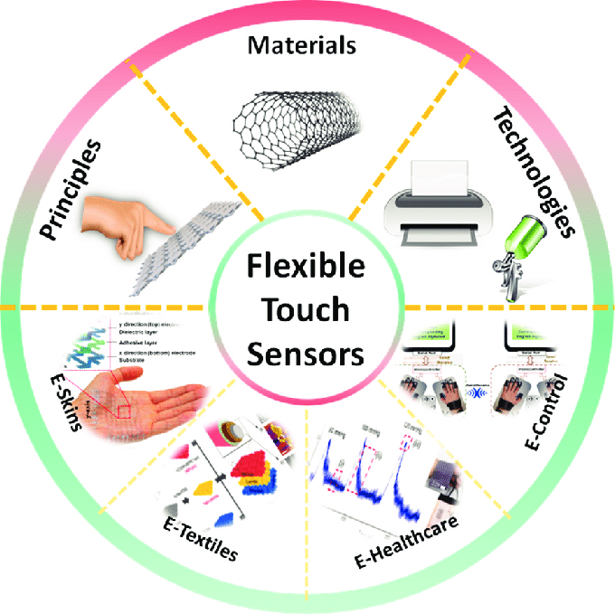

Use Case 2: Wearable Technology Control

* Description: Using touch sensors as input devices for wearable technology.
* Application: Touch-sensitive surfaces on sleeves or accessories can control music playback, answer calls, or adjust settings on connected devices. This is common in smart jackets, gloves, or wristbands.

Use Case 3: Virtual Fitting Rooms

* Description: Employing touch sensors in fabrics for virtual fitting rooms.
* Application: Touch-sensitive areas on clothing allow users to interact with virtual interfaces, changing colors, patterns, or trying on different clothing options in a virtual environment. This enhances the retail experience and aids in online shopping.
  1. **Interactive e-textile applications and examples**

1. Smart Fabrics:
   * Temperature-Regulating Clothing: Fabrics embedded with heating or cooling elements that adjust to the wearer's body temperature.
   * Thermochromic Textiles: Fabrics that change color based on temperature changes.
2. Wearable Health Monitoring:
   * Biometric Clothing: Garments equipped with sensors to monitor vital signs such as heart rate, respiratory rate, and body temperature.
   * Posture-Correcting Apparel: Clothing that provides haptic feedback or gently vibrates to alert the wearer to maintain proper posture.
3. Fashion Tech:
   * Interactive Fashion Shows: Garments equipped with LED lights or other electronic elements that change based on motion or external stimuli during runway shows.
   * Sound-Responsive Clothing: Fabrics that respond to sound or music by changing colors or patterns.
4. Safety and Visibility:
   * Light-Up Safety Gear: Reflective clothing with integrated LEDs for increased visibility in low-light conditions.
   * Gesture-Controlled Accessories: Hats or bags with embedded sensors that respond to specific gestures, providing a safety signal or activating features.
5. Educational Tools:
   * Textile-Based Sensors: Educational kits incorporating textile-based sensors to teach electronics and programming in a hands-on way.
   * Interactive Storytelling Textiles: Textiles with embedded sensors that trigger audio or visual elements when touched, enhancing storytelling experiences for children.
6. Entertainment and Gaming:
   * Gaming Apparel: Clothing with sensors that respond to in-game events, providing a tactile experience for gamers.
   * LED-Embedded Costumes: Costumes with programmable LED lights for themed events or performances.
7. Assistive Technology:
   * Haptic Navigation Clothing: Garments that provide haptic feedback to help individuals navigate their surroundings.
   * Emotional Expression Clothing: Wearable textiles that change patterns or colors based on the wearer's emotional state, aiding non-verbal communication.
8. Sports and Fitness:
   * Smart Sportswear: Athletic clothing with embedded sensors to monitor performance metrics such as motion, heart rate, and muscle activity.
   * Gesture-Controlled Sport Accessories: Sports gear that responds to specific gestures for hands-free control.

**Challenges and Future Trends**

* 1. **Current challenges in e-textile development**

1. Integration of Electronics with Textiles:
   * *Flexibility and Durability:* Ensuring that electronic components can withstand the flexibility and movements of textiles without compromising their performance or durability.
   * *Washability:* Developing electronic textiles that can withstand washing and other common textile care processes without damaging the electronic components.
2. Power Sources:
   * *Energy Storage:* Designing efficient and lightweight energy storage solutions, such as batteries or energy-harvesting systems, to power electronic components without adding excessive weight or bulk to the textiles.
   * *Longevity:* Ensuring that power sources have a sufficient lifespan to match the expected lifespan of the textile product.
3. Compatibility and Standardization:
   * *Interoperability:* Establishing industry standards to ensure compatibility between different e-textile components and systems, promoting interoperability and facilitating collaboration among manufacturers.
   * *Connectivity:* Addressing challenges related to connectivity protocols, ensuring seamless communication between different electronic elements within the textiles.
4. Cost and Scalability:
   * *Production Costs:* Reducing the production costs associated with e-textiles to make them more accessible for mass-market adoption.
   * *Scalability:* Developing scalable manufacturing processes to meet the demands of large-scale production without compromising quality.
5. User Comfort and Aesthetics:
   * *Comfort:* Balancing the integration of electronic components with the comfort and wearability of textiles to ensure that users find the products comfortable for extended periods.
   * *Aesthetics:* Incorporating electronic elements in a way that enhances the aesthetic appeal of the textiles and aligns with fashion and design trends.
6. Sustainability:
   * *Material Selection:* Choosing sustainable and environmentally friendly materials for both the textile and electronic components to minimize the environmental impact of e-textile production and disposal.
   * *Recyclability:* Designing e-textiles with end-of-life considerations in mind, making it easier to recycle or repurpose electronic components.
7. Regulatory Compliance:
   * *Safety Standards:* Adhering to safety and regulatory standards for electronic products, especially those in close contact with the human body, to ensure user safety and compliance with international regulations.
8. Education and Skill Development:
   * *Workforce Skills:* Addressing the need for skilled professionals in both electronics and textiles who can collaborate effectively to advance e-textile technology.
   * *Public Awareness:* Raising awareness and educating consumers about the capabilities, care, and benefits of e-textiles to promote widespread acceptance and adoption.
9. Miniaturization and Component Integration:
   * *Size Constraints:* Overcoming challenges related to miniaturizing electronic components while maintaining their functionality.
   * *Multifunctionality:* Integrating multiple functions into a single e-textile without sacrificing performance or increasing complexity.
   1. **Emerging technologies in the field**
10. *Integration of Electronics with Textiles:*
    * *Flexibility and Durability: Ensuring that electronic components can withstand the flexibility and movements of textiles without compromising their performance or durability.*
    * *Washability: Developing electronic textiles that can withstand washing and other common textile care processes without damaging the electronic components.*
11. *Power Sources:*
    * *Energy Storage: Designing efficient and lightweight energy storage solutions, such as batteries or energy-harvesting systems, to power electronic components without adding excessive weight or bulk to the textiles.*
    * *Longevity: Ensuring that power sources have a sufficient lifespan to match the expected lifespan of the textile product.*
12. *Compatibility and Standardization:*
    * *Interoperability: Establishing industry standards to ensure compatibility between different e-textile components and systems, promoting interoperability and facilitating collaboration among manufacturers.*
    * *Connectivity: Addressing challenges related to connectivity protocols, ensuring seamless communication between different electronic elements within the textiles.*
13. *Cost and Scalability:*
    * *Production Costs: Reducing the production costs associated with e-textiles to make them more accessible for mass-market adoption.*
    * *Scalability: Developing scalable manufacturing processes to meet the demands of large-scale production without compromising quality.*
14. *User Comfort and Aesthetics:*
    * *Comfort: Balancing the integration of electronic components with the comfort and wearability of textiles to ensure that users find the products comfortable for extended periods.*
    * *Aesthetics: Incorporating electronic elements in a way that enhances the aesthetic appeal of the textiles and aligns with fashion and design trends.*
15. *Sustainability:*
    * *Material Selection: Choosing sustainable and environmentally friendly materials for both the textile and electronic components to minimize the environmental impact of e-textile production and disposal.*
    * *Recyclability: Designing e-textiles with end-of-life considerations in mind, making it easier to recycle or repurpose electronic components.*
16. *Regulatory Compliance:*
    * *Safety Standards: Adhering to safety and regulatory standards for electronic products, especially those in close contact with the human body, to ensure user safety and compliance with international regulations.*
17. *Education and Skill Development:*
    * *Workforce Skills: Addressing the need for skilled professionals in both electronics and textiles who can collaborate effectively to advance e-textile technology.*
    * *Public Awareness: Raising awareness and educating consumers about the capabilities, care, and benefits of e-textiles to promote widespread acceptance and adoption.*
18. *Miniaturization and Component Integration:*
    * *Size Constraints: Overcoming challenges related to miniaturizing electronic components while maintaining their functionality.*
    * *Multifunctionality: Integrating multiple functions into a single e-textile without sacrificing performance or increasing complexity.*
    1. **Speculations on the future of e-textiles:**
19. Advanced Integration with Augmented Reality (AR) and Virtual Reality (VR):
    * E-textiles may become seamlessly integrated with AR and VR technologies. Clothing and accessories could incorporate smart textiles that interact with virtual environments, enhancing immersive experiences.
20. Biometric Data for Personalized Experiences:
    * E-textiles could play a key role in collecting and analyzing biometric data for personalized experiences. Clothing might adapt based on physiological indicators, optimizing comfort, and well-being.
21. Energy Harvesting and Self-Powered Textiles:
    * Future e-textiles might incorporate advanced energy-harvesting technologies, allowing garments to generate and store energy from the environment. This could lead to self-powered textiles capable of supporting embedded electronics.
22. Enhanced Connectivity and IoT Integration:
    * E-textiles are likely to become integral components of the Internet of Things (IoT). Clothing and accessories may seamlessly connect to smart homes, devices, and other IoT-enabled infrastructure for enhanced communication and functionality.
23. Biodegradable and Sustainable E-Textiles:
    * A growing emphasis on sustainability may lead to the development of biodegradable and environmentally friendly e-textiles. Researchers and designers may focus on creating electronic components that can be easily recycled or integrated into sustainable materials.
24. Flexible and Stretchable Electronics:
    * Continued advancements in flexible and stretchable electronics could result in e-textiles that are more comfortable, durable, and adaptable to various body shapes and movements.
25. Fashion-Tech Fusion:
    * The convergence of fashion and technology may lead to the widespread acceptance of e-textiles in mainstream fashion. Designers may incorporate smart textiles into everyday clothing, blurring the lines between fashion and technology.
26. AI-Enhanced Smart Textiles:
    * Integration with artificial intelligence (AI) could enable smart textiles to learn and adapt to user preferences over time. AI algorithms may analyze data from sensors to optimize the functionality and responsiveness of e-textiles.
27. Medical and Health Monitoring Applications:
    * E-textiles may play a crucial role in remote health monitoring. Garments with embedded sensors could continuously track various health parameters, providing valuable data for healthcare professionals.
28. Customizable and Programmable Textiles:
    * Future e-textiles may offer increased customization, allowing users to program and personalize the behavior of their clothing. This could range from changing colors and patterns to modifying functionality based on individual preferences.
29. Rapid Prototyping and DIY E-Textile Kits:
    * The development of user-friendly e-textile kits and tools could empower individuals to create their own interactive clothing and accessories. This could lead to a DIY (do-it-yourself) culture in e-textile design and innovation.

**Conclusion**

* 1. **Future Prospects**

1. Healthcare and Medical Applications:
   * E-textiles have the potential to revolutionize healthcare by providing continuous monitoring of vital signs, detecting health anomalies, and offering non-invasive diagnostic capabilities. Smart garments could play a crucial role in remote patient monitoring and personalized healthcare.
2. Human-Computer Interaction (HCI):
   * Advances in e-textiles can contribute to the evolution of human-computer interaction. Clothing with embedded sensors could enable more natural and intuitive interactions with computers and other devices, paving the way for gesture-based controls and augmented reality interfaces.
3. Military and Defense Innovations:
   * E-textiles can be integrated into military uniforms and equipment, offering features such as real-time health monitoring, communication capabilities, and adaptive camouflage. The lightweight and flexible nature of e-textiles makes them suitable for various military applications.
4. Sports Performance and Training:
   * Smart sportswear with embedded sensors can provide athletes with real-time data on their performance, helping optimize training routines, prevent injuries, and enhance overall athletic performance. E-textiles could become integral to the sports industry.
5. Smart Fabrics for Environmental Monitoring:
   * E-textiles can be utilized for environmental monitoring, with fabrics embedded with sensors to measure pollution levels, radiation, or other environmental factors. This could be particularly useful in industrial settings or areas prone to environmental hazards.
6. E-Textile Fashion Industry Growth:
   * The fashion industry is likely to witness a surge in e-textile integration, with designers exploring innovative ways to incorporate technology into clothing and accessories. Interactive and customizable garments could become more commonplace in retail and high-end fashion.
7. Educational Tools and STEAM Initiatives:
   * E-textiles offer a hands-on and engaging way to teach science, technology, engineering, arts, and mathematics (STEAM) concepts. Educational kits and programs that incorporate e-textiles may inspire the next generation of innovators and creators.
8. Integration with Smart Homes and IoT Ecosystems:
   * As smart homes and IoT ecosystems continue to expand, e-textiles can seamlessly integrate with these systems. Clothing and textiles with embedded sensors could interact with smart home devices, enhancing automation and user experience.
9. Wearable Assistive Technologies:
   * E-textiles can contribute to the development of wearable assistive technologies for individuals with disabilities. Smart garments could assist with mobility, communication, and daily living activities, promoting greater independence.
10. Entertainment and Gaming Experiences:
    * E-textiles have the potential to enhance entertainment experiences, particularly in gaming and virtual reality. Clothing with haptic feedback, dynamic lighting, and interactive features could provide a more immersive and engaging entertainment environment.
11. Cross-Industry Collaborations:
    * Collaborations between industries, such as fashion, technology, healthcare, and automotive, will likely drive innovative applications of e-textiles. These interdisciplinary partnerships could lead to groundbreaking solutions with diverse applications.
    1. **Resources:**

https://etextile.org/

<https://www.wikipedia.org/>

<https://deepai.org/>

https://www.wearabletechnologyinsights.com/